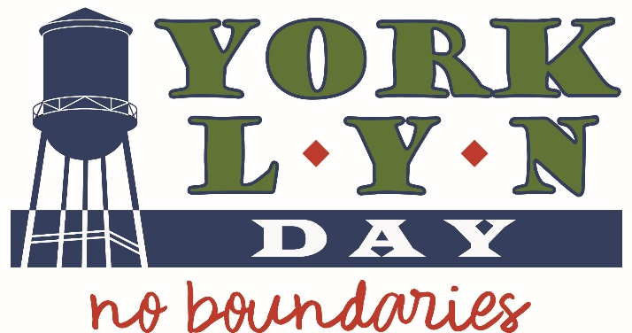

Sign Me Up to be a Yorklyn Day Booster

Date
Name
Street Address
City/State/Zip
Phone Email
T-Shirt Size (Adult Unisex Sizes Small through 2XL)
*Name to acknowledge on program/website
Check if in honor of or in memory of
Payment Method Check (payable to FAHP) Credit Card (Mastercard, Visa, Discover)
Card #
Exp Date CVV Billing Zip CVV
Signature

Please make all checks payable to FAHP
(To pay by credit card over the phone, call the FAHP office at 302-239-2385)

Please return form with your payment to:
F.A.H.P.
Yorklyn Day
P.O. Box 61
Yorklyn DE 19736

Questions? Contact Susan Randolph at 302-239-2385; info@YorklynDay.org or visit YorklynDay.org

